Exercise 1.1

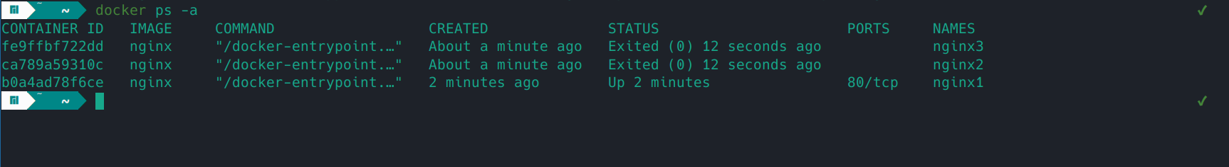

Exercise 1.2

